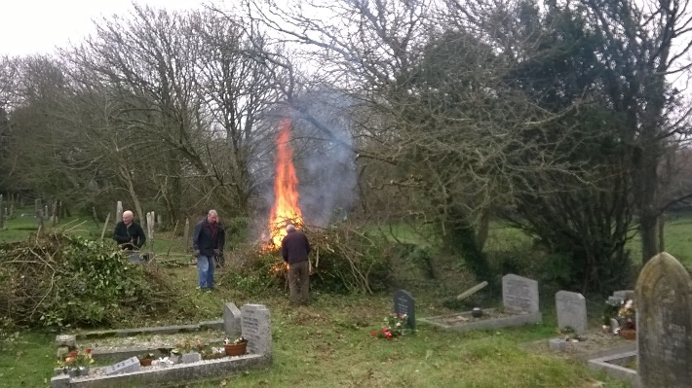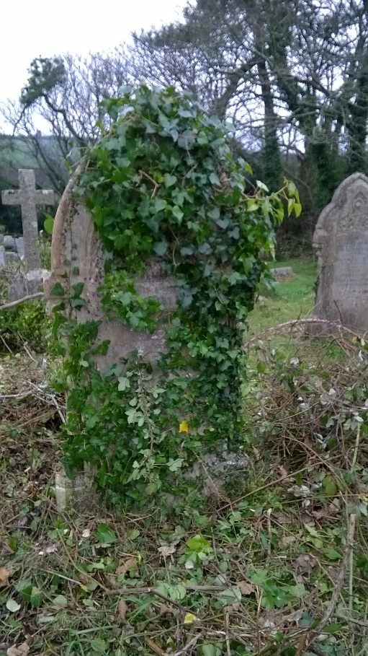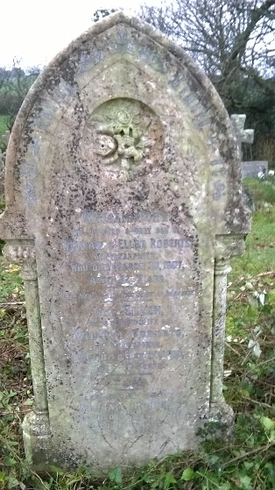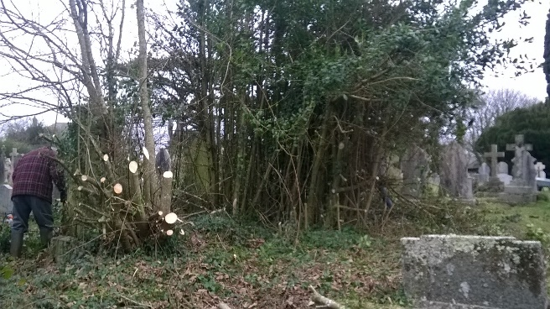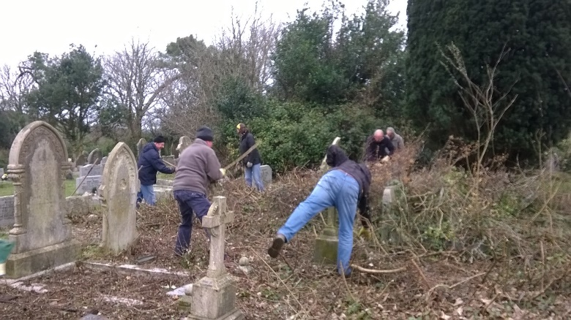After

***Friends of St Piran’s Churchyard   
January 2019 Report 4***

The first Saturday saw an enthusiastic band of 20 volunteers arrive to continue the work of recovering the graveyard.

Refreshments were provided by Jean, Mary and Christine who had the warming soup, sausage rolls, cake and drinks on offer.

The main focus of the work was centred on areas P and N continuing the clearance work on the thickets in those areas.

A large bonfire, once going, dealt swiftly with the massive amount of material that was cleared, and for the first time in numerous years the war graves are ‘just’ about visible from the main path, however more work is still required, to improve visibility.

Some gravestones, like the Richards one, to the right, had their ivy carefully removed to expose some wonderful stone and leaded work, while others had their grass and weeds removed from around them.

Work was also begun in area A1, behind the war memorial, so that the church will again be visible to cars travelling along the main road.

Rubbish was collected from around the graveyard and memorial gardens.

The next working party will be February 2nd 10-2, all are welcome, either to join in or just come and see what is happening.

There will also be a meeting in the Green Parrot upper room, on Monday 21st January for review of work undertaken so far and to plan for the coming months.

Thanks to all involved – your hard work is making massive difference to this wonderful space.

(Apologies for there being no report for December, I was away and had not tagged someone else to do it, but suffice to say, work happened in and around areas MNOP)